AI Engineer Programming Test: Agentic AI
Objective:
Assess the candidate's ability to design and implement a simple agentic AI system using multi-agent orchestration, incorporating Retrieval-Augmented Generation (RAG).
Framework Options:
Candidates can choose one of the following free and simple frameworks:
- Langchain/Langgraph
- OpenAI Agents SDK
Tools & Requirements:
- Data Handling: Standard Python libraries and a simple local file (e.g., a .txt file) to simulate a knowledge base.
- LLM: The candidate can use any LLM available in the market (Or please send an email to kanit.mekritthikrai@bangkokbank.com to grant the access to the following gpt-5-mini
endpoint = "https://oaibblinnocandiddate01.openai.azure.com/"
model_name = "gpt-5-mini"
deployment = "gpt-5-mini"
subscription_key = "<contact>"
- Required Skills: Python programming, basic understanding of RAG, API interaction, and prompt design.
Scenario:
Build a system with two agents:
- "Data Retriever" Agent (RAG): Specializes in retrieving specific information from a provided knowledge base (a simple text file). It does not answer questions directly but provides relevant text snippets.
- "Report Generator" Agent: Receives the snippets from the Data Retriever and synthesizes them into a cohesive, non-redundant, and well-formatted answer to a user's query.
Task Instructions:
Create a text file named knowledge_base.txt containing a few paragraphs of sample information (e.g., company policies, product descriptions, or general facts about a topic like "cats").
Agent Definitions:
- Data Retriever:
  - Role/Instructions: Expert in information retrieval. Searches the knowledge_base.txt file for all snippets relevant to the user's request.
  - Tool: Implement a custom Python function/tool that reads the knowledge_base.txt file and performs a simple keyword or basic semantic search. The agent should be configured to use this tool.
  - Output: Return raw, relevant text chunks to the Report Generator.
- Report Generator:
    - Role/Instructions: Expert writer and synthesizer. Uses the provided information snippets to formulate a comprehensive, high-quality answer for the end-user.
    - Tool: No additional tools needed.
    - Output: The final, polished answer presented to the user.
Task Orchestration:
- Orchestrate a sequential workflow where the Data Retriever's output is passed as input to the Report Generator.
- Candidates using the OpenAI Agents SDK/Langchain should use either a "handoff" pattern or an "agent-as-tool" pattern or any other pattern to coordinate the two agents.
Execution and Evaluation:
- Run the system with a sample query (e.g., "What is the policy on international travel?").
- The candidate should submit the complete Python code, the knowledge_base.txt file, and a screenshot of the final output for a few different queries on the github repository.
- Evaluation Criteria:
- Correct use of the chosen framework to define agents and orchestrate the workflow.
- Effective implementation of the RAG mechanism (the custom data retrieval tool).
- Clarity and quality of the final output (non-redundant, accurate based on provided info, well-formatted).
- Code structure, readability, and adherence to Python best practices.

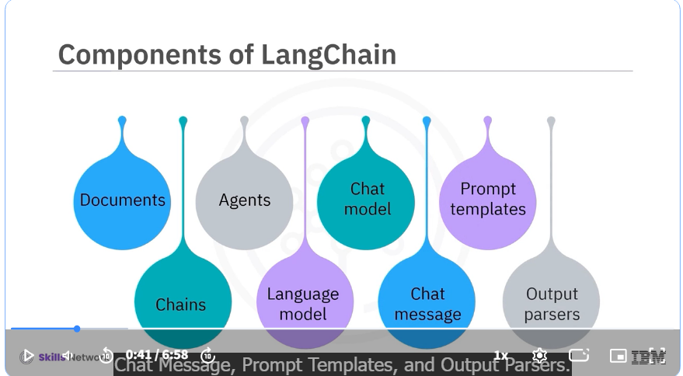
LangChain Language and Chat Models
- Language models generate text output from text input, supporting tasks like summarization and content generation using providers like IBM WatsonX.AI.
- Chat models extend language models to handle conversational interactions with different message types (human, AI, system, function, tool) for dynamic dialogue.
Prompt Templates and Example Selectors
- Prompt templates convert user inputs into clear instructions for the language model, supporting various formats like string prompts and chat prompts with role-based messages.
- Example selectors optimize prompt templates by choosing relevant examples to guide the model’s output, using methods like semantic similarity and n-gram overlap.
Output Parsers
- Output parsers transform raw LLM outputs into structured formats such as JSON, CSV, or data frames, enabling easier data handling and analysis in applications.
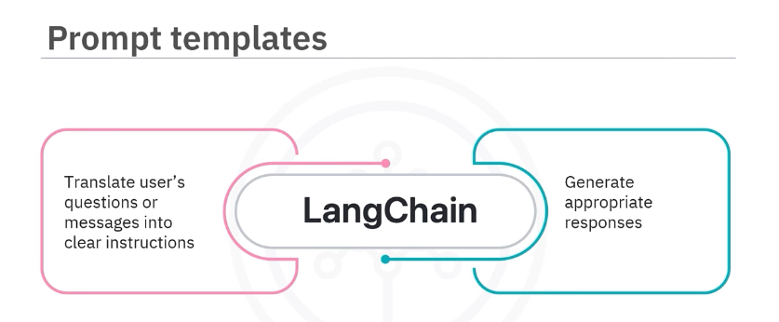
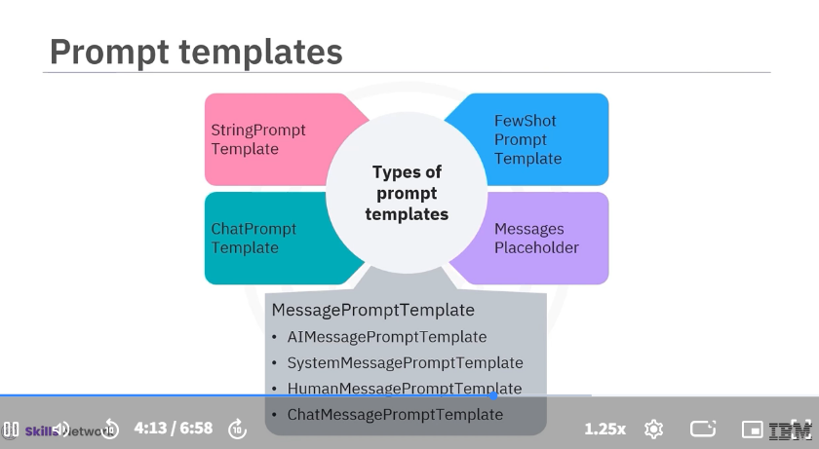
LangChain Language and Chat Models
- Language models generate text output from text input, supporting tasks like summarization and content generation using providers like IBM WatsonX.AI.
- Chat models extend language models to handle conversational interactions with different message types (human, AI, system, function, tool) for dynamic dialogue.
Prompt Templates and Example Selectors
- Prompt templates convert user inputs into clear instructions for the language model, supporting various formats like string prompts and chat prompts with role-based messages.
- Example selectors optimize prompt templates by choosing relevant examples to guide the model’s output, using methods like semantic similarity and n-gram overlap.
Output Parsers
- Output parsers transform raw LLM outputs into structured formats such as JSON, CSV, or data frames, enabling easier data handling and analysis in applications.
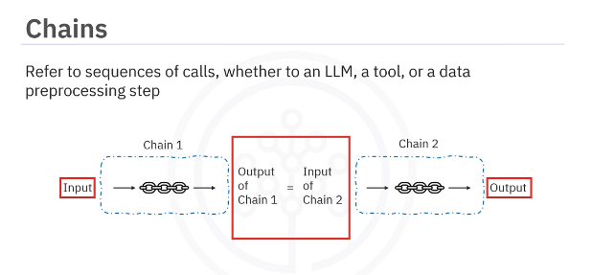
LangChain, chains are like a series of connected steps where each step uses the output from the previous one to move forward.
Chains in LangChain
- Chains are sequences of calls where each step's output becomes the next step's input, enabling a smooth flow of information.
- Example: A sequential chain with three steps identifies a famous dish by location, provides its recipe, and estimates cooking time.
Memory Storage in LangChain
- Memory stores historical data to maintain context across interactions by reading and writing inputs and outputs.
- The ChatMessageHistory class manages conversation history, allowing the system to remember both AI and user messages.
Agents in LangChain
- Agents dynamically decide and sequence actions using language models but rely on external tools to execute tasks.
- Example: A Pandas DataFrame agent interprets natural language queries, converts them to code, and returns precise data insights.
3chains example

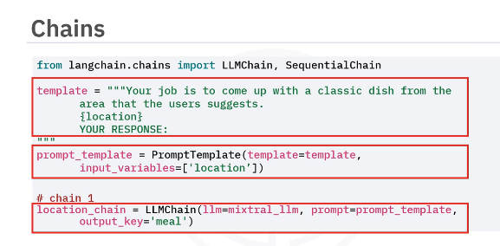
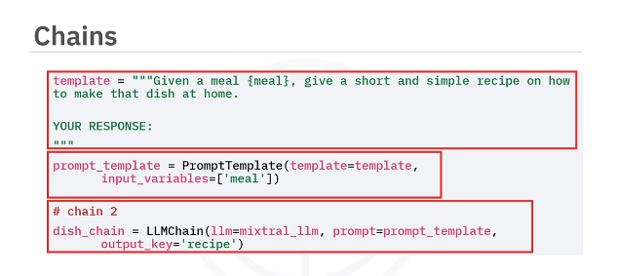
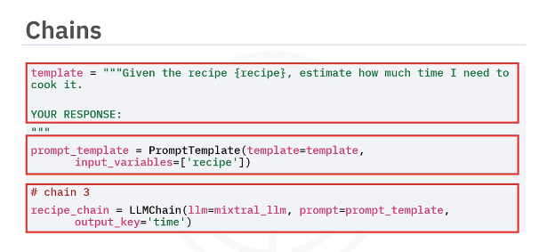
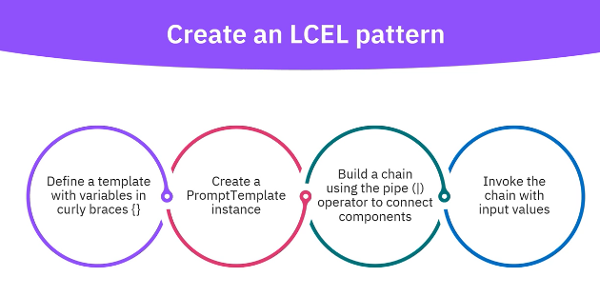
LCEL Pattern and Components
- LCEL uses the pipe operator to connect components, creating a clear and readable data flow from input to output.
- Prompts are structured with templates containing variables in curly braces, and prompt templates are instantiated for use in chains.
Runnable Composition and Pipe Operator
- RunnableSequence chains components sequentially, while RunnableParallel runs multiple components concurrently with the same input.
- LCEL simplifies syntax by replacing RunnableSequence with the pipe operator and automatically converts functions and dictionaries into runnable components.
Practical Usage and Benefits
- LCEL supports parallel execution, async operations, simplified streaming, and automatic tracing, enhancing application power and maintainability.
- It is best suited for simpler orchestration tasks, with LangGraph recommended for more complex workflows, while still using LCEL within nodes.
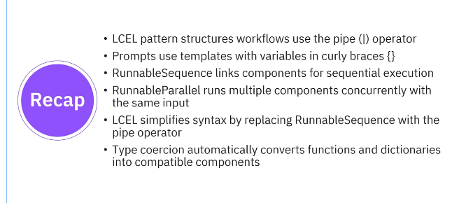

Core GenAI Concepts & Terminologies
Foundational Concepts
Term | Definition | Examples/Use Cases
LLM | A type of AI model trained on vast amounts of text data to understand and generate human-like language. | GPT-o1, Claude, LLaMA
Prompting | A technique for designing input instructions to guide LLM outputs. | "Write a summary in 3 sentences," "Answer as a cybersecurity expert."
Prompt Templates | Reusable, structured prompts with placeholders for dynamic inputs. | "Explain {concept} like I'm 5 years old."
RAG (Retrieval-Augmented Generation) | Combines retrieval from external knowledge sources with LLM generation to enhance factual accuracy. | Answering questions with real-time data (for example, RAG Paper)
Retriever | A system component designed to fetch relevant information from a dataset or database. | Vector similarity search using FAISS, Elasticsearch
Agent | An autonomous AI system that can plan, reason, and execute tasks using tools. | AutoGPT, LangChain Agents
Multi-Agent System | A framework in which multiple AI agents collaborate to solve complex tasks. | Microsoft AutoGen, CrewAI
Chain-of-Thought | A prompting technique that encourages models to decompose problems into intermediate steps. | "Let's think step by step…"
Hallucination Mitigation | Strategies to reduce incorrect or fabricated outputs from LLMs. | RAG, fine-tuning, prompt constraints
Vector Database | A database optimized for storing and querying vector embeddings. | Pinecone, Chroma, Weaviate
Orchestration | Tools to manage and coordinate workflows involving multiple AI components. | LangChain, LlamaIndex
Fine-tuning | Adapting pre-trained models for specific tasks using domain-specific data. | LoRA (Low-Rank Adaptation), QLoRA (quantized fine-tuning)
Tools & Frameworks
Model Development & Deployment
Tool/Framework | Definition | Examples/Use Cases | Reference Link
Hugging Face | A platform hosting pre-trained models and datasets for NLP tasks. | Accessing GPT-2, BERT, Stable Diffusion | Hugging Face
LangChain | A framework for building applications with LLMs, agents, and tools. | Creating chatbots with memory and web search | LangChain
AutoGen | A library for creating multi-agent conversational systems. | Simulating debates between AI agents | AutoGen
CrewAI | A framework for assembling collaborative AI agents with role-based tasks. | Task automation with specialized agents | CrewAI
BeeAI | A lightweight framework to build production-ready multi-agent systems | Distributed problem-solving systems | BeeAI
LlamaIndex | A tool to connect LLMs to structured or unstructured data sources. | Building Q&A systems over private documents | LlamaIndex
LangGraph | A library for building stateful, multi-actor applications with LLMs. | Cyclic workflows, agent simulations | LangGraph
Retrieval & Infrastructure
Tool/Framework | Definition | Examples/Use Cases | Reference Link
FAISS | A library for efficient similarity search of dense vectors. | Retrieving top-k documents for RAG | FAISS
Pinecone | A managed cloud service for vector database operations. | Storing embeddings for real-time retrieval | Pinecone
Haystack | An end-to-end framework for building RAG pipelines. | Deploying enterprise search systems | Haystack
Advanced Prompting Techniques
Concept | Definition | Example
Few-Shot Prompting | Providing examples in the prompt to guide the model's output format. | "Translate to French: 'Hello' → 'Bonjour'; 'Goodbye' → __”
Zero-Shot Prompting | Directly asking the model to perform a task without examples. | "Classify this tweet as positive, neutral, or negative: {tweet}”
Chain-of-Thought | Encouraging step-by-step reasoning. | "First, calculate X. Then, compare it to Y. Final answer: ___”
Prompt Chaining | Breaking complex tasks into smaller prompts executed sequentially. | Prompt 1: Extract keywords → Prompt 2: Generate summary from keywords.
Key Architectures & Workflows
RAG Pipeline
- Retrieval: Query vector database (for example, Pinecone) for context.
- Augmentation: Combine context with user prompt.
- Generation: LLM (for example, GPT-4) produces final output.
Multi-Agent System
- Agents: Specialized roles (for example, researcher, writer, critic).
- Orchestration: LangGraph for cyclic workflows, AutoGen for conversations, and so on.

Introduction to LangChain
LangChain Framework and Benefits
- LangChain provides modular components and interfaces that help developers integrate LLMs into AI applications efficiently.
- Key benefits include modularity for reusable components, extensibility for adding features and integrating external systems, and decomposition to break down complex tasks into manageable steps.
Practical Applications of LangChain
- It can summarize complex documents, extract key data from reports, support sophisticated question-answer systems, and automate routine content generation tasks.
- LangChain also integrates with vector databases to enable efficient semantic search and retrieval from large datasets.
Support for Multiple Data Types
- While primarily text-focused, LangChain can work with images, audio, and video by leveraging external models and libraries.
- This capability allows it to perform similarity searches and semantic understanding across various data types, broadening its use in AI applications.
LangChain integrates with vector databases by using embeddings—numerical representations that capture the semantic meaning of text or other data types. Here's how it works:
- LangChain generates embeddings from text or other data (like images or audio) using external models.
- These embeddings are stored in vector databases, which are optimized for fast similarity searches.
- When a query is made, LangChain converts it into an embedding and performs a semantic search in the vector database.
- The database returns the most relevant information based on semantic similarity, which LangChain then uses to generate accurate and contextually relevant responses.

LangChain Retrievers
- A LangChain retriever is an interface that returns documents based on an unstructured query.
- It accepts a string query and returns a list of documents or chunks, serving as a retrieval mechanism rather than a storage system.
Vector Store-Based Retriever
- This retriever works by querying an existing vector database created from source documents that are chunked and embedded.
- It retrieves the most similar chunks by embedding the query and performing similarity search or maximum marginal relevance (MMR).
Similarity Search and MMR
- Similarity search retrieves documents most similar to the query based on embedding comparison.
- MMR balances relevance and diversity by selecting documents that are relevant but minimally similar to each other, reducing redundancy and improving coverage.

